**UGANDA CERTIFICATE OF LOWER SECONDARY EDUCATION**

**END OF YEAR ASSESSMENT 2024**

**SENIOR FOUR**

**PHYSICS: THEORY**

**Time allowed: 2 hour 15 minutes**

**P**

**lease**

**write clearly in block capitals**

**Index Number:**

**Name:**

**Signature:**

**Materials**

For this paper you must have:

✓

a ruler

✓

a scientific calculator

**Instructions**

**:**

✓

Use black ink or black ball

-

point pen.

✓

Fill in the boxes at the top of this page.

✓

Answer all questions in the space

provided

in section A

.

✓

U

se separate answer sheets for section B

✓

In all calculations, show clearly how you work out your

answer.

**Information**

✓

There are 100 marks available on this paper.

✓

The marks for questions are shown in brackets.

✓

You are reminded of the need for good English and clear

presentation in your answers

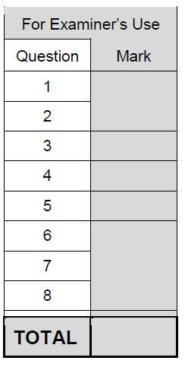

**SECTION A**

*(Attempt* ***all*** *questions in this section)* 1. **Figure 1** shows a balloon filled with helium gas.

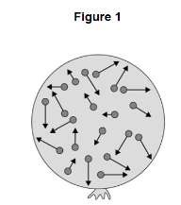

1. Describe the movement of the particles of helium gas inside the balloon.

(01 mark)

………………………………………………………………………………………………………

……………………………………………………………………………………………………… ……………………………………………………………………………………………………..

1. What name is given to the total kinetic energy and potential energy of all the particles of helium gas in the balloon? Tick one box.

(01 mark)

|  |
| --- |
|  |
|  |
|  |

External energy

Internal energy

Movement energy

1. Write down the equation which links density, mass and volume.

(01 mark)

……………………………………………………………………………………………………

…………………………………………………………………………………………………… …………………………………………………………………………………………………… (d) The helium in the balloon has a mass of 0.00254 kg. The balloon has a volume of 0.0141 m3. Calculate the density of helium. Choose the correct unit from the box.

(03 marks)

|  |  |  |  |  |  |  |  |  |
| --- | --- | --- | --- | --- | --- | --- | --- | --- |
| m3kg-1 |  |  |  | kgm-3 |  |  |  | kgm3 |

………………………………………………………………………………………………………..

………………………………………………………………………………………………………..

……………………………………………………………………………………………………….

(e) A student wants to calculate the density of the two objects shown in Figure 2.

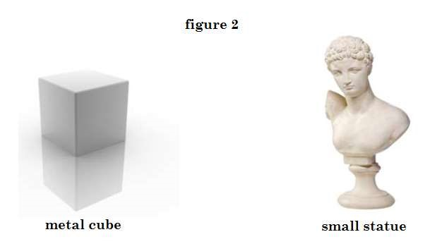

(i) Describe the methods that the student should use to calculate the densities of the two objects. (04 marks)

…………………………………………………………………………………………………………

…………………………………………………………………………………………………………

…………………………………………………………………………………………………………

…………………………………………………………………………………………………………

…………………………………………………………………………………………………………

………………………………………………………………………………………………………… …………………………………………………………………………………………………………

…………………………………………………………………………………………………………

…………………………………………………………………………………………………………

…………………………………………………………………………………………………………

…………………………………………………………………………………………………………

…………………………………………………………………………………………………………

…………………………………………………………………………………………………………

…………………………………………………………………………………………………………

…………………………………………………………………………………………………………

…………………………………………………………………………………………………………

…………………………………………………………………………………………………………

…………………………………………………………………………………………………………

…………………………………………………………………………………………………………

…………………………………………………………………………………………………………

…………………………………………………………………………………………………………

…………………………………………………………………………………………………………

2. **Figure 3** shows an unusually shaped container. The container has four vertical tubes of different shape and size. Water is poured into the container up to the level shown in tube 1.

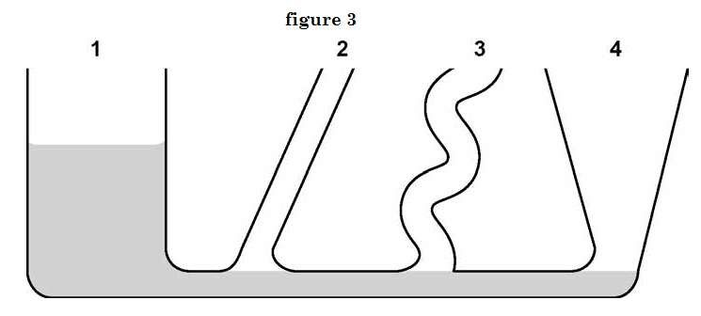

1. Complete Figure 3 to show the height of the water in tubes 2, 3 and 4

(01 mark)

1. The further a swimmer dives below the surface of the sea, the greater the

pressure on the swimmer. Explain why. (02 marks)

…………………………………………………………………………………………………………

…………………………………………………………………………………………………………

…………………………………………………………………………………………………………

1. Nakato and Babirye are two women with the same mass 50kg, but wear different types of shoes. Nakato wears a high heeled pair of shoes with area in contact with the ground 200cm2 while Babirye wears flat shoes with area in contact 400cm2. Which woman exerts the highest pressure on the ground? With reason which shoes can you recommend for wearing on the soft ground? (03 marks)

…………………………………………………………………………………………………………

…………………………………………………………………………………………………………

…………………………………………………………………………………………………………

1. Describe an experiment to show that pressure in liquids at the same depth act equally in all directions. (04 marks)

…………………………………………………………………………………………………………

…………………………………………………………………………………………………………

…………………………………………………………………………………………………………

…………………………………………………………………………………………………………

…………………………………………………………………………………………………………

…………………………………………………………………………………………………………

…………………………………………………………………………………………………………

…………………………………………………………………………………………………………

…………………………………………………………………………………………………………

…………………………………………………………………………………………………………

………………………………………………………………………………………………………… …………………………………………………………………………………………………………

3. **Figure 4** shows a view from above of a vertical mirror. A small lamp is placed at the point marked L.

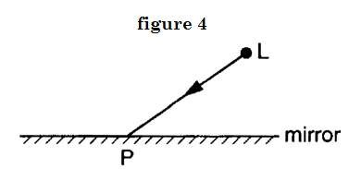

(a) One ray, LP, from the lamp has been drawn.

1. At P, draw and label the normal to the mirror.
2. At P, draw and label the reflected ray.
3. Mark, using an X for each, two angles which are equal. (03 marks)
4. Carefully mark, using a clear dot, the position of the image of the lamp.

(02marks)

1. If you were looking into the mirror from point L, you might see something like

**Figure 5** “looking back at you”. (Apologies if you are better looking than this!)

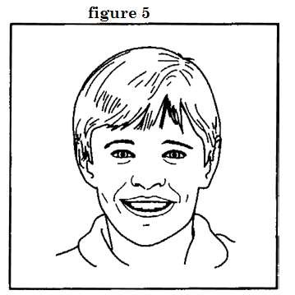

* 1. Mark clearly with the letter R, the image of your right ear. (01 mark)
  2. Your nose is 30 cm from the mirror. How far from your nose is its image?

(02 marks)

…………………………………………………………………………………………………………

…………………………………………………………………………………………………………

…………………………………………………………………………………………………………

…………………………………………………………………………………………………………

…………………………………………………………………………………………………………

…………………………………………………………………………………………………………

1. State the laws of reflection of light (02 marks)

…………………………………………………………………………………………………………

…………………………………………………………………………………………………………

…………………………………………………………………………………………………………

…………………………………………………………………………………………………………

1. A dish of hot food is put on a wooden table as shown in **figure 6**

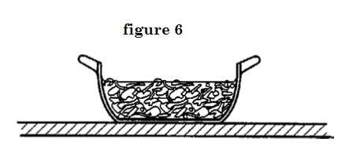

(a) State three processes by which the dish and its contents could lose heat to the surroundings. (03 marks)

…………………………………………………………………………………………………………

………………………………………………………………………………………………………… ………………………………………………………………………………………………………… (b) (i) Describe one way of reducing the heat loss to the surroundings.

(01mark)

…………………………………………………………………………………………………………

………………………………………………………………………………………………………… …………………………………………………………………………………………………………

(ii) Which form of heat loss would this reduce? (01 mark)

…………………………………………………………………………………………………………

…………………………………………………………………………………………………………

…………………………………………………………………………………………………………

(c) Here are some statements about energy. Complete the statements using words from the following list.

***chemical, electrical, geothermal, heat, hydroelectric, light, movement (kinetic), position (potential), strain, tidal, wave***

(i) A coal fire converts …………………………………….. Energy into

…………………………….energy and……………………….. Energy

(03 marks)

(ii) When a ball falls from rest, it’s ………………………energy increases and its……………………………….. Energy decreases.

(02 marks)

(iii) The source of energy, in which hot rocks under the Earth's surface heat water to produce steam, is referred to as

…………………………………energy. (01 mark)

1. Part of the thermometer that is used to determine the fall in temperature is shown in **Figure 7.** The diagram shows the thermometer before and after adding the ammonium chloride.
   1. Record each of the temperatures and determine the fall in temperature.

Temperature before adding the ammonium chloride = ……………………..

Temperature after adding the ammonium chloride = ………………………..

Fall in temperature = …………………………………………… (03 marks)

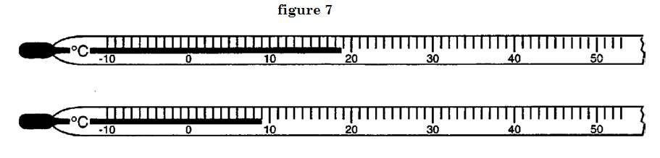

* 1. Convert the two readings of the thermometer to Kelvin scale (02 marks)

…………………………………………………………………………………………………………

…………………………………………………………………………………………………………

…………………………………………………………………………………………………………

* 1. In **Figure 7** the liquid thread is shown along the edge of the scale marks. This is the recommended way to position the liquid thread before reading a temperature. In **Figure 8** the thread is positioned away from the edge of the scale.

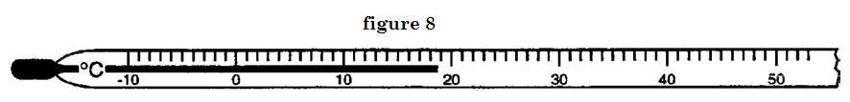

Suggest a reason for the recommended way to use a thermometer. (01 mark)

…………………………………………………………………………………………………………

…………………………………………………………………………………………………………

…………………………………………………………………………………………………………

* 1. Three students had an argument on how the lower fixed point can be determined, as a physics student describe with the aid of a diagram the proper way of determining the

lower fixed point. (03 marks)

…………………………………………………………………………………………………………

…………………………………………………………………………………………………………

…………………………………………………………………………………………………………

…………………………………………………………………………………………………………

…………………………………………………………………………………………………………

…………………………………………………………………………………………………………

* 1. Explain why it is advisable to connect a manometer to a hypsometer during an

experiment to determine the upper fixed point. (01 mark)

…………………………………………………………………………………………………………

…………………………………………………………………………………………………………

…………………………………………………………………………………………………………

…………………………………………………………………………………………………………

…………………………………………………………………………………………………………

…………………………………………………………………………………………………………

SECTION B (Attempt only 3 questions)

1. Some smoke is mixed with the air in a glass box. The box is lit brightly from the side and its contents studied from above through a microscope.

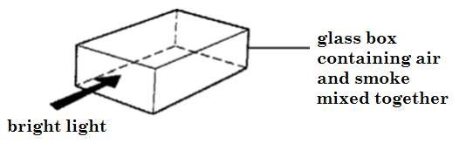

* + 1. Bright specks are seen moving in continuous and jerky random movement. (i) What are the bright specks? Tick one box.

Air molecules

Smoke molecules

Smoke particles

* + 1. What is the explanation for the jerky random movement? Choose your answer(s) from the selection below

*The air molecules bombard each other.*

*The smoke particles bombard each other.*

*The air molecules bombard the smoke particles.*

*The air molecules bombard the glass.*

*The smoke particles bombard the glass.*

(i) Fill the correct answer in the box below.

(c) Predict what will happen if :

* + - 1. A pin is placed on the surface of clean water powered in a clean trough

* + - 1. A blotting paper is placed on clean water surface then a pin gently placed on the paper and the setup is left for some time.
      2. Explain your statements in c (i) and (ii)
      3. Explain what would happen if the soap solution is gently added in the water solution in c(ii) using a syringe. (10 marks)

1. A waiter at hotel Africana holds a tray horizontally in one hand between fingers and thumb as shown in the diagram. P, Q and W are the three forces acting on the tray.

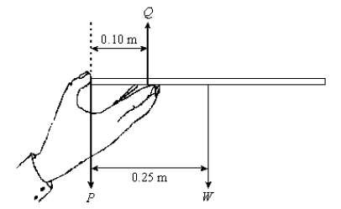

* + - 1. (i) State two relationships between the forces that must be satisfied if the tray is to remain horizontal and in equilibrium.

* + - 1. If the mass of the tray is 0.12 kg, calculate the magnitude of the force W

* + - 1. Calculate the magnitudes of forces P and Q.
      2. Define the moment of a force and state its SI units.
      3. What effect of a force is shown in Figure below (10 marks)

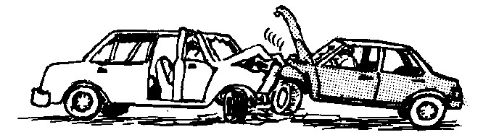

1. You are given an iron bar, a reel of insulated wire, a battery and some wire cutters.

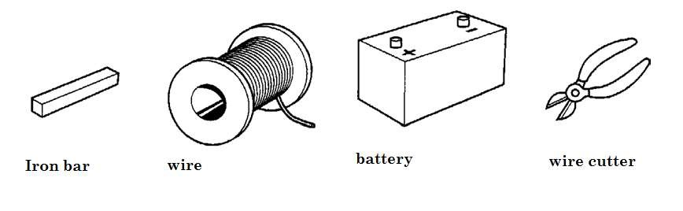

(a) In the space below, describe how you would make an electromagnet. You may use a labelled diagram if it helps you to answer the question. (b) How would you check that your electromagnet actually works?

(c) State three properties of magnetic field (10 marks)

1. What is a scientific investigation?

(a)Why is the step of making observation in the process of scientific investigation very important?

(c)How is scientific investigation different from non-scientific investigation? Give examples.

(d) Discuss the meanings of the following terms:

(i) Prediction (ii) Interpretation of result

(iii) Data analysis (iv) Decision making (10 marks)

1. (a)Explain why it is important to observe laboratory rules and regulations (b) You are working in the laboratory and you see the hazard symbols shown in Figure below:

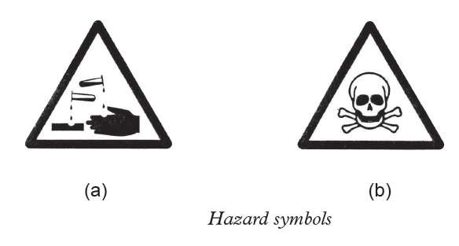

* + - 1. Describe the meaning of each symbol.
      2. Describe the steps you would take to guard against the hazard depicted by each symbol.

(c) In every school, there is a procedure to be followed by every member of the school community in case of fire outbreak. Describe the procedure to be followed

in your school. (10 marks)

END